Uploaded the static website code from local repo to Github repo by creating the new branch as staging.

git init

git clone https://github.com/Gotoman12/StaticWebsite-code.git

cd StaticWebsite-code (where I copied the folder and files)

admin@DESKTOP-IJJL0A6 MINGW64 /e/html-website-templates-master/Animated Landing Page Website Template/StaticWebsite-code (main)
$ git checkout main
Already on 'main'
Your branch is up to date with 'origin/main'.

admin@DESKTOP-IJJL0A6 MINGW64 /e/html-website-templates-master/Animated Landing Page Website Template/StaticWebsite-code (main)
$ git pull origin main
From https://github.com/Gotoman12/StaticWebsite-code
* branch main -> FETCH_HEAD
Already up to date.

admin@DESKTOP-IJJL0A6 MINGW64 /e/html-website-templates-master/Animated Landing Page Website Template/StaticWebsite-code (main)
$ git checkout -b staging
Switched to a new branch 'staging'

admin@DESKTOP-IJJL0A6 MINGW64 /e/html-website-templates-master/Animated Landing Page Website Template/StaticWebsite-code (staging)
$ ls -a
./ ../ .git/ README.md assets/ css/ index.html js/

admin@DESKTOP-IJJL0A6 MINGW64 /e/html-website-templates-master/Animated Landing Page Website Template/StaticWebsite-code (staging)
$ git add .
warning: in the working copy of 'css/styles.css', LF will be replaced by CRLF the next time Git touches it
warning: in the working copy of 'index.html', LF will be replaced by CRLF the next time Git touches it
warning: in the working copy of 'js/scripts.js', LF will be replaced by CRLF the next time Git touches it

admin@DESKTOP-IJJL0A6 MINGW64 /e/html-website-templates-master/Animated Landing Page Website Template/StaticWebsite-code (staging)
$ git status
On branch staging
Changes to be committed:
(use "git restore --staged <file>..." to unstage)
new file: assets/favicon.ico
new file: assets/img/bg-masthead.jpg
new file: assets/img/bg-signup.jpg
new file: assets/img/demo-image-01.jpg
new file: assets/img/demo-image-02.jpg
new file: assets/img/ipad.png
new file: css/styles.css
new file: index.html
new file: js/scripts.js

admin@DESKTOP-IJJL0A6 MINGW64 /e/html-website-templates-master/Animated Landing Page Website Template/StaticWebsite-code (staging)
$ git commit -m "uploaded the static website files/folder"
[staging e2d3a2c] uploaded the static website files/folder
9 files changed, 11462 insertions(+)
create mode 100644 assets/favicon.ico
create mode 100644 assets/img/bg-masthead.jpg
create mode 100644 assets/img/bg-signup.jpg
create mode 100644 assets/img/demo-image-01.jpg
create mode 100644 assets/img/demo-image-02.jpg
create mode 100644 assets/img/ipad.png
create mode 100644 css/styles.css
create mode 100644 index.html
create mode 100644 js/scripts.js

admin@DESKTOP-IJJL0A6 MINGW64 /e/html-website-templates-master/Animated Landing Page Website Template/StaticWebsite-code (staging)
$ git push
fatal: The current branch staging has no upstream branch.
To push the current branch and set the remote as upstream, use

git push --set-upstream origin staging

To have this happen automatically for branches without a tracking
upstream, see 'push.autoSetupRemote' in 'git help config'.

admin@DESKTOP-IJJL0A6 MINGW64 /e/html-website-templates-master/Animated Landing Page Website Template/StaticWebsite-code (staging)
$ git push --set-upstream origin staging
Enumerating objects: 16, done.
Counting objects: 100% (16/16), done.
Delta compression using up to 4 threads
Compressing objects: 100% (13/13), done.
Writing objects: 100% (15/15), 1.09 MiB | 1.08 MiB/s, done.
Total 15 (delta 0), reused 0 (delta 0), pack-reused 0 (from 0)
remote:
remote: Create a pull request for 'staging' on GitHub by visiting:
remote: https://github.com/Gotoman12/StaticWebsite-code/pull/new/staging
remote:
To https://github.com/Gotoman12/StaticWebsite-code.git
* [new branch] staging -> staging
branch 'staging' set up to track 'origin/staging'.

https://github.com/Gotoman12/StaticWebsite-code.git

Create a sample Jenkins CICD pipeline and share output logs and pipeline script:
Console Log:
Started by user admin

Obtained Jenkinsfile from git https://github.com/Gotoman12/StaticWebsite-code.git
[Pipeline] Start of Pipeline
[Pipeline] node
Running on Jenkins
in C:\ProgramData\Jenkins\.jenkins\workspace\sample Jenkins CICD pipeline
[Pipeline] {
[Pipeline] stage
[Pipeline] { (Declarative: Checkout SCM)
[Pipeline] checkout
Selected Git installation does not exist. Using Default
The recommended git tool is: NONE
No credentials specified
> git.exe rev-parse --resolve-git-dir C:\ProgramData\Jenkins\.jenkins\workspace\sample Jenkins CICD pipeline\.git # timeout=10
Fetching changes from the remote Git repository
> git.exe config remote.origin.url https://github.com/Gotoman12/StaticWebsite-code.git # timeout=10
Fetching upstream changes from https://github.com/Gotoman12/StaticWebsite-code.git
> git.exe --version # timeout=10
> git --version # 'git version 2.51.2.windows.1'
> git.exe fetch --tags --force --progress -- https://github.com/Gotoman12/StaticWebsite-code.git +refs/heads/*:refs/remotes/origin/* # timeout=10
> git.exe rev-parse "origin/main^{commit}" # timeout=10
Checking out Revision 08bbd33c655859dbccc02838e0e113b88e55a587 (origin/main)
> git.exe config core.sparsecheckout # timeout=10
> git.exe checkout -f 08bbd33c655859dbccc02838e0e113b88e55a587 # timeout=10
Commit message: "added new stage"
First time build. Skipping changelog.
[Pipeline] }
[Pipeline] // stage
[Pipeline] withEnv
[Pipeline] {
[Pipeline] stage
[Pipeline] { (GIT-CHECKOUT)
[Pipeline] git
Selected Git installation does not exist. Using Default
The recommended git tool is: NONE
No credentials specified
> git.exe rev-parse --resolve-git-dir C:\ProgramData\Jenkins\.jenkins\workspace\sample Jenkins CICD pipeline\.git # timeout=10
Fetching changes from the remote Git repository
> git.exe config remote.origin.url https://github.com/Gotoman12/StaticWebsite-code.git # timeout=10
Fetching upstream changes from https://github.com/Gotoman12/StaticWebsite-code.git
> git.exe --version # timeout=10
> git --version # 'git version 2.51.2.windows.1'
> git.exe fetch --tags --force --progress -- https://github.com/Gotoman12/StaticWebsite-code.git +refs/heads/*:refs/remotes/origin/* # timeout=10
> git.exe rev-parse "refs/remotes/origin/staging^{commit}" # timeout=10
Checking out Revision 0904ce41efb981e2018403f484759b90889068e3 (refs/remotes/origin/staging)
> git.exe config core.sparsecheckout # timeout=10
> git.exe checkout -f 0904ce41efb981e2018403f484759b90889068e3 # timeout=10
> git.exe branch -a -v --no-abbrev # timeout=10
> git.exe branch -D staging # timeout=10
> git.exe checkout -b staging 0904ce41efb981e2018403f484759b90889068e3 # timeout=10
Commit message: "uploaded the doc file"
> git.exe rev-list --no-walk 0904ce41efb981e2018403f484759b90889068e3 # timeout=10
[Pipeline] }
[Pipeline] // stage
[Pipeline] stage
[Pipeline] { (Hello-World)
[Pipeline] echo
Pipeline is completed
[Pipeline] }
[Pipeline] // stage
[Pipeline] }
[Pipeline] // withEnv
[Pipeline] }
[Pipeline] // node
[Pipeline] End of Pipeline
Finished: SUCCESS

Pipeline screenshot:
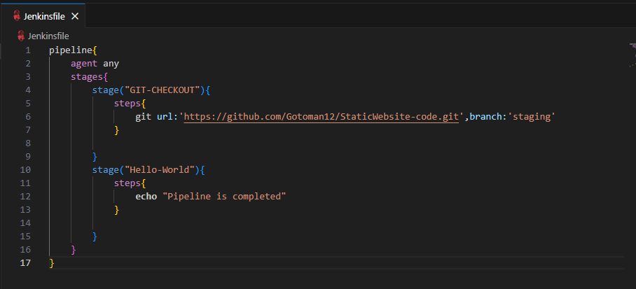

I created a pipeline for my project to test the API:

pipeline {
agent any
tools {
nodejs 'NodeJS'
}
stages {
stage('Check Node Version') {
steps {
bat 'node --version'
}
}
stage('run the API Test') {
steps {
bat 'node --version'
}
}
stage('install newman') {
steps {
bat 'npm install -g newman'
}
}
stage('install newman-reporter-htmlextra') {
steps {
bat 'npm install -g newman-reporter-htmlextra'
}
}
stage('GIT CHECKOUT') {
steps {
git url:"https://github.com/Gotoman12/API-Testing.git",branch:'main'
}
}
stage('RUN API Using Newman CLI') {
steps {
bat '''
newman run "API Collection\\Simple Book API.postman_collection" ^
-e "API Collection\\QA.postman_environment.json" -r cli,htmlextra --reporter-htmlextra-export newman-report.html"
'''
}
}
}
post{
always{
// Archive HTML report in Jenkins
archiveArtifacts artifacts: 'newman-report.html', fingerprint: true

// Email the HTML report
emailext (
subject: "Newman Test Report - Build #${env.BUILD_NUMBER}",
body: """\
Hello Team,

The Newman API test run is complete.
Please find the attached HTML test report.

Regards,
Jenkins
""",
to: "mallikarjunckm@gmail.com",
attachmentsPattern: "newman-report.html"
)
}
}
}

